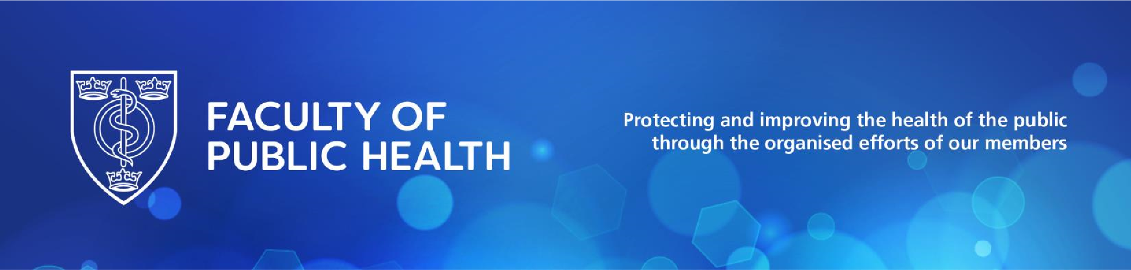

Littlejohn Gairdner Prize

Foundation

This prize was instituted by Dorothy Hedderwick to commemorate the centenary of the appointment of her father, Sir Henry Duncan Littlejohn, as Medical Officer for Edinburgh and his friend, Sir William Tennant Gairdner, as Medical Officer of Health for Glasgow.

Funding/purpose

The prize aims to celebrate outstanding contributions to public health in Scotland from early career professionals.

The Littlejohn Gairdner Prize Fund and/or its proceeds shall be used to offer a cash prize and a medal to FPH members in Scotland who are undertaking specialty training, the UKPHR or GMC portfolio routes or working as a public health practitioner.

Administration of the Littlejohn Gairdner Prize Fund shall be the responsibility of the Scottish Committee of the Faculty of Public Health.

Eligibility

Members of the Faculty of Public Health who are:

- Undertaking public health specialty training in Scotland
- Undertaking the UKPHR or GMC portfolio routes in Scotland
(Applicants undertaking the UKPHR portfolio route will need to provide evidence from UKPHR, eg, a confirmation letter or email from UKPHR)
- Working as a public health practitioner in Scotland and hold FPH Practitioner Membership (PFPH)

Candidates will be allowed to apply more than once unless they have won the prize previously.

Application

Applications should be a written submission, either as a single piece of work or as a number of linked pieces together forming a theme. The length of the submission should be in the range of 2,500 words.

The application should demonstrate how the applicant has led or significantly contributed to a programme of work to improve outcomes and reduce inequalities.

The work can be in any discipline of public health: health protection, health improvement or health care public health.

Criteria for award

The work should demonstrate a high level of subject knowledge and/or technical expertise in one or more of the above areas of public health, as well as excellent judgement in the application of said knowledge and/or expertise to a public health issue. This includes demonstration of appropriate consultation, sensitivity to local and national policy, good quality presentation and ability to make astute recommendations.

The submission must demonstrate:

- A strong commitment to tackling inequalities and disparities in health
- Leadership across a project or programme of work
- Strong evidence of partnership working
- A commitment to integrating learning into practice

The award may be carried over to the next year at the discretion of the adjudication panel in the absence of applications of sufficient merit.

Adjudication

The prize and medal will be awarded on the recommendation of the adjudication panel, subject to confirmation by the Committee of the Faculty of Public health in Scotland.

The adjudication panel will be appointed by the Committee of the Faculty of Public Health in Scotland.

Value

£100 agreed in 2005.

Frequency of award

Annually, funds permitting.

Closing date

The closing date for submissions is announced on the FPH website each year: Annual awards and prizes - FPH - Faculty of Public Health

Presentation

Award of the medal and prize money shall be made at the annual Faculty of Public Health awards ceremony.

Recipients shall be required, as a condition of the award, to deliver an address to be known as the Littlejohn Gairdner memorial lecture based on an aspect of the prize-winning work to the annual Faculty of Public Health Scottish conference

Applications should be sent to the FPH education team at educ@fph.org.uk. For further information, please contact the education team via email at educ@fph.org.uk or by phone 020 3696 1451.

