

LOGISTICS OF THE OSPHE

The Candidate Experience

- Exam held at GMC centre

- Purpose built, easy to locate

- Given a badge on entry, wear all day

- Must arrive on time
- Quite long waits from entry until exam starts

- Can get tedious as just want to get started

- Initial waiting area is large, open planned, airy

- Free to chat, drinks/toilets available

- Quite good atmosphere
- Registration in separate room (remember ID)

- Place belongings in locker

- Through to third waiting area

- Instructions on chairs, fairly extensive

- Kept in here until morning candidates leave
- Lunch (need to pre-order), takes up time

- Briefing for candidates – informative

- Again, surprisingly relaxed atmosphere in room

- BUT glad when it was time to start

- GMC staff on hand, seemed experienced

- Faculty staff calm and friendly
- Go to the toilet just before starting!

- Given a pack with all 6 stations details as you enter the circuit

- Carry throughout the exam, can make notes

- No real time to look ahead to see what is coming

- Stay calm, no need to panic
- Told which station you start at (always a preparation station)

- Six candidates start before the other six

- Staff on hand to guide, clearly marked

- Clear timing, system of TV monitors & tannoy

- Warnings at start, one minute remaining and at end

- Worked well, easy to follow
- No time to dwell on previous station

- Try to move on to next station and forget

- Water available in preparation rooms

- Not always enough cups

- Takes time to find cup, open water and pour

- Don’t drink too much
- Time went very quickly

- Not particularly stressful as no time to reflect

- Have to return pack before exiting circuit

- Six candidates finish earlier than other six

- Fill in evaluation sheet whilst fresh
- Clear your locker

- Don’t listen too much to other candidates!

- Relax afterwards, don’t reflect excessively

- Results do come out quickly so not long to wait

The Exam

Scenarios, Briefings, Tasks
Exam Circuit

- 6 P and 6 E rooms

- 1 min outside P room

- 8 min preparation – 1 min warning

- 1 min outside E room

- 8 min exam – 1 min warning

- Cycle continues till you finish 6 E stations
Preparation Stations

- Desk

- Preparation pack / briefing

- Pens/Pencils/ Paper / Marker pens/Flip chart

- Clock

- Water / cups
Preparation pack

- Briefing material – 1 to 5 pages long

- Can make notes on it

- Refer to it in your exam discussion

- Tasks – reasonably clear

- Use of flip chart

- Timing – 8 min pass quickly

- No health protection scenario!
Exam stations

- Examiners

– Check ID

– Introduce scenario/actor

– Assist you to put up flip chart

– No further participation

– Friendly, professional, formal
Exam stations

- Actors

– Professional actors / PH consultants

– Generally friendly, appropriate behaviour

– Wait for you to start the conversation

– Sometimes difficult to get the point across

– Could be different for am/pm sessions
Task 1 – Hospital CEO

- You lead a health promotion project

- Poor participation from hospital

- Explain importance to hospital and the population in general

- Ask for active support from hospital

- Briefing – good

- Use flip chart?

- Actor – very appropriate for CEO
Task 2 - PH manager

- Community hospital closure

- How to evaluate outcomes before/after closure
- Briefing – one page email only

- Actor – appropriate PH understanding, supportive
Task 3 - Comms person

- Outline a press release

- Important PH issue

- Briefing – about 2 pages, relevant

- Actor – alright
Task 4 – LA manager

- Gain their support to do HEA – for important PH issue
- Briefing – okay, more general info than specific for conducting this HEA
- Actor – difficult to get the points across
Task 5 - Health Authority CEO

- New investment - important disease area

- Advise CEO

- Differing priorities - clinicians / PH

- Briefing – a bit long, a bit confusing

- Use flip chart?

- Actor – appropriate for CEO
Task 6 – Patients’ Mum

- Her child undergoing operation

- Explain side effects / complications

- Informed consent – NICE study

- Briefing – a bit long but appropriate

- Actor – alright

- Scenario – too clinical!!
Top Tips 1

- Get involved in the role

- Read quickly – pick out key points

- Focus exactly on the task

- Use a framework and structure your presentation
- Language appropriate to the audience

- Be polite, empathise, keep calm

- Check understanding
Top Tips 2

- Use all the props appropriately

– Maps, Tables, Flip charts

- Few key points to get across

- Address all 5 competencies

- Relax and organise your framework / thoughts during the 1 min gap
- Switch off totally once outside the E room and on again in the new P room

How to prepare
Practice…..

- Speed reading and assimilation of key points

– NHS / DH documents

– NICE guidance

– Your or colleague’s project work

– OSPHE examples on the website!

• In 8 min – timing is important

Practice…..

- Presenting to different audiences

– CEO

– PH professionals / managers

– Public

– Media

- Appropriate tone, language

- Get across important messages

- In 8 min – timing is important

- Practice with work colleagues, trainers

- Go for full mock exam – if possible

- Prepare your generic framework

- Try to embrace and enjoy the role

- Cover all the 5 competencies in your presentation
- Ask the ‘examiner’ to specifically comment and feedback on all 5 competencies

Preparation for the OSPHE in your Training Programme

Anne Scoular

Preparation: an overview

• Understand what is being assessed

• Personal preparation

• Using workplace opportunities
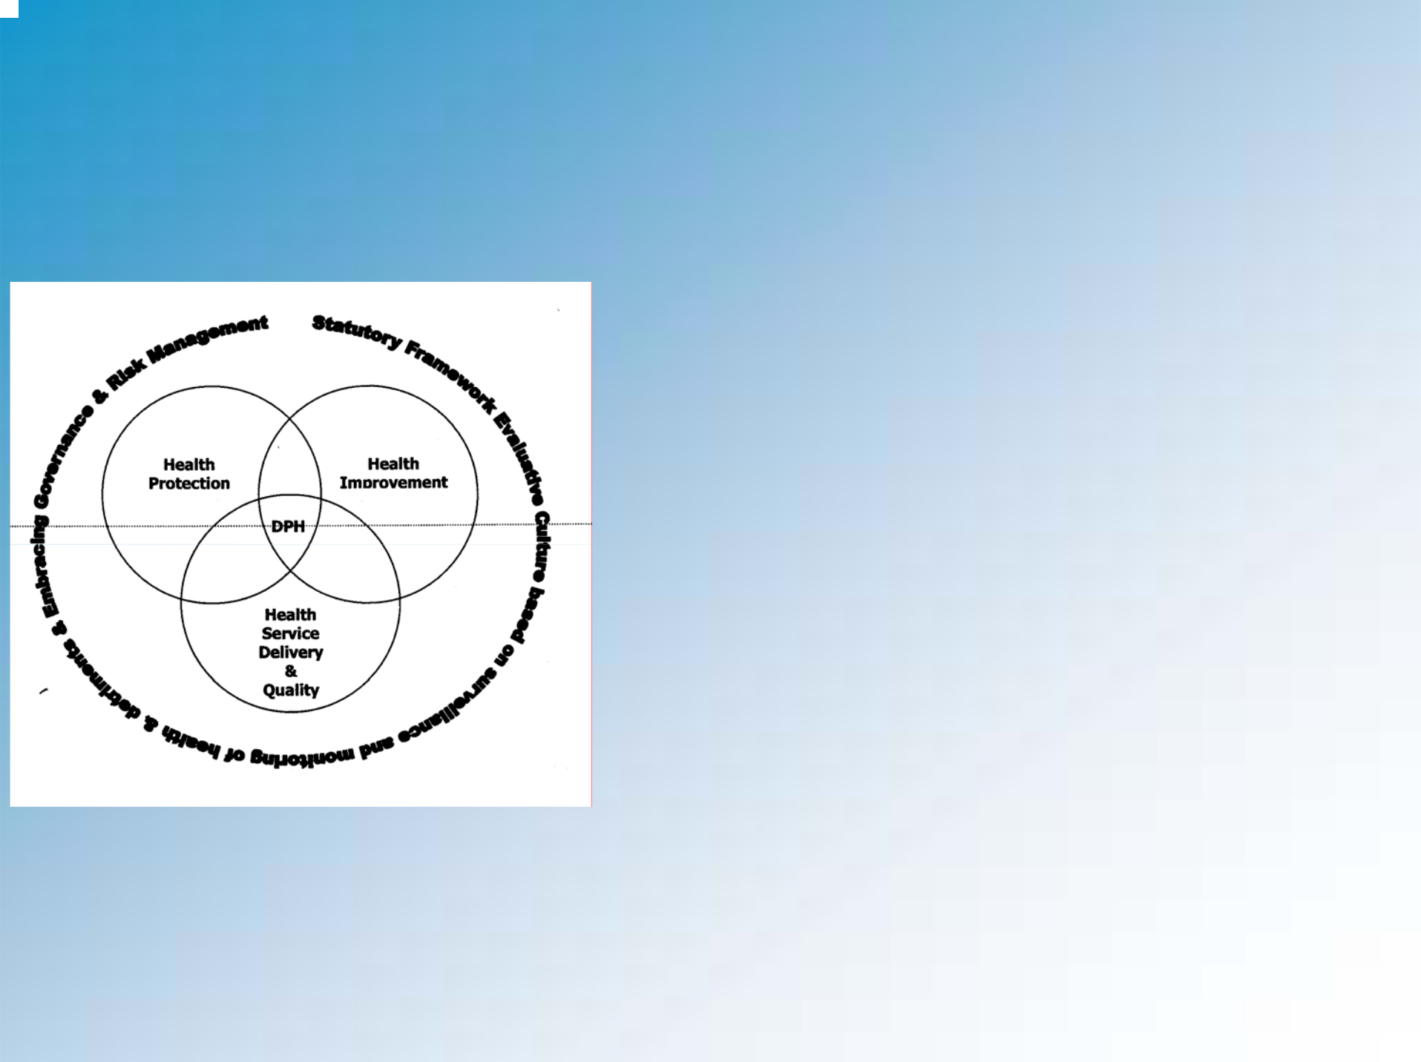
Understand what is being assessed

- Three domains of Public Health practice

- Application of theory to practice

- 5 specific competencies

  - Communication skills: presenting

  - Communication skills: listening, comprehending, responding

  - Assimilating & using relevant information

  - Reasoning, analytical and judgement skills;giving a balanced view

  - Handling of uncertainty, the unexpected, challenge and conflict
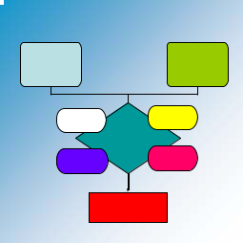
Personal preparation

Analysis of the problem

Rapid reading &
Main questions/issues

Epidemiology | Health Protection

Existing (simple) frameworks

Health Service | Health Improvement
Delivery & quality

PRODUCT

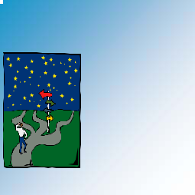
Personal preparation

• Rapid reading

– Journal editorials

– Policy documents

– Summary papers

• Distillation of key facts

• Application to a context (any !)

• Communication skills

– Methods

– Content

– Audience

– Pace

– Get feedback

– Consider video-recording

And even more personal….

• Reflect on your communication

• Know your strengths & weaknesses

- Be aware of non-verbal signals

- Use all opportunities to practice

- Expect OSPHE to be stressful…!

– plan appropriately

– personal strategies
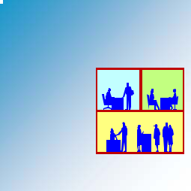
Using workplace opportunities

- Presentations to groups

– Formal

– Informal

- 1:1 communication

– methods

– content

– non-verbal communication

– ask for feedback

– reflect

– Develop

- Media training

- Risk communication


Using workplace opportunities

• Group learning

– Use The Faculty of Public Health Diplomate examination (DFPH) Qs

– Apply to real context

– Role play

– Experienced colleagues

• Video recordings

• Mock OSPHE

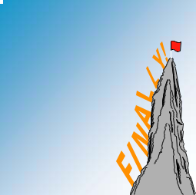
Top tips

- Understand the assessment process

- Develop your own frameworks

- Capitalise on everyday opportunities:

– Analyse

– Reflect

– Practice

- On the day:

– Keep it simple

– Go with the flow

– Aim for clarity

– Don’t talk too much

– Remember what is being assessed

