Guidance for Deaneries and Colleges on Combined Programme applications

Contents
Guidance for Deaneries and Colleges on Combined Programme applications 1
Purpose of this guidance 2
What is the combined programme? 2
Policy 2
As the granting of CCTs is subject to the legislation that was in place at the point the GMC granted entry to the specialist/GP register, we are unable to grant all previous combined programme doctors with a CCT. Retrospective requests for a CCT 2
Deanery responsibilities 3
College responsibilities 4
Enrolment on a training programme through the combined programme pathway 4
Identify when a trainee is working towards the award of a CCT via a Combined Programme application. 4
College confirmation of appointment onto combined programme 5
Apply to the GMC for approval of trainee’s appointment at higher entry level 5
Applying for specialist/GP registration through the combined programme 7
Process for application 7
Retrospective granting of CCT to CESR(CP) holders 7
Verification of requirements for retrospective requests 8
Annex A - Required minimum training times for all UK specialties 9
Doctors on a dual training programme 9
Doctors training with a sub-specialty 10
Additional training time 10
Locum appointments for specialty training 10
Required minimum training times for all UK specialties 10

Purpose of this guidance
This guidance outlines the additional steps required of Deaneries and Colleges on appointment of trainees to a combined programme, and the policy and process for retrospective granting of a Certificate of Completion of Training (CCT) to eligible doctors previously granted a Certificate of Eligibility for Specialist Registration (CESR) or Certificate of Eligibility for General Practice Registration(CEGPR) through the Combined Programme.

What is the combined programme?
Some trainees wish to join an approved specialist training programme having previously undertaken training or gained experience in posts that weren’t prospectively approved by the GMC. The combined programme provides a pathway through which this previous experience can be recognised and lead to less than the indicative training time spent in an approved programme.
Deaneries, Health Education and Improvement Wales and Health Education England local teams (from here referred to as ‘deaneries’), and Royal Colleges and Faculties (from here referred to as ‘colleges’) can decide that this non-approved training, experience and/ or qualifications has allowed a trainee to develop some of the professional capabilities required by the approved curriculum. The trainee can then enter into an approved training programme above the usual entry point, and go on to complete the remainder of the programme within approved posts. For example, a trainee could be recruited into higher specialist training at ST3, having demonstrated through their previous training and/or experience that they hold the competencies we would expect a trainee to hold at the end of core training.
Once appointed onto an approved training programme, the training of those on a combined programme is managed following the same processes as a CCT trainee.
These trainees can make an application for entry to the specialist or GP register, at the completion of the combined programme.

Policy
All doctors who complete a combined programme can apply for entry to the specialist/GP register. From 1 January 2021 any doctor on a combined programme whose application for entry on to the specialist or GP register is approved by the GMC will be granted a CCT.

As the granting of CCTs is subject to the legislation that was in place at the point the GMC granted entry to the specialist/GP register, we are unable to grant all previous combined programme doctors with a CCT. Retrospective requests for a CCT
Where a doctor who completed a combined training programme was erroneously issued with a CESR or CEGPR on being granted entry to the specialist/GP register from 1 January 2021, we will proactively rectify this, and issue them with a CCT.
Prior to 2021 we were subject to EU legislation which set out, for the majority of specialties, a minimum amount of time that doctors must have spent in approved training in the UK (see Annex A). Under that legislation doctors who trained through the combined programme pathway were all originally issued with a CESR or CEGPR. However, as part of our work to improve the flexibility of postgraduate medical education and training, we received legal advice which presented an alternative interpretation of the legislation, enabling us to begin issuing CCTs to some doctors on the combined programme.
In 2020 we began to issue CCTs to doctors on a combined programme who had completed the minimum amount of time training in the UK for their specialty, or who trained in a specialty for which there was no minimum training time. We also applied this retrospectively.
Combined programme trainees who did not meet the minimum UK training time for their specialty will not be eligible to be granted a CCT retrospectively.
These changes only apply to trainees on the combined programme. There are no changes to the main CESR/CEGPR route to specialist/GP registration.
This guidance explains the responsibilities of deaneries and colleges in these processes.

Deanery responsibilities
- Identify when a trainee is working towards the award of a CCT via a Combined Programme application.
- Apply to the GMC for approval of a trainee’s entry into training at a higher entry point than usual.
- Submit information to college in the usual way at the end of training, for trainee to be recommended for a CCT.

College responsibilities
- Approval of deanery appointment of trainee onto the combined programme.
- Recommend the trainee for a CCT in the usual way at the end of training.
- Verification of requirements for retrospective requests, where required.

Enrolment on a training programme through the combined programme pathway
The GMC’s process for applicants joining training through the combined programme pathway and working towards a CCT is set out below.

Identify when a trainee is working towards the award of a CCT via a Combined Programme application.
- When a trainee is recruited onto a combined programme pathway to specialist/GP registration, the professional capabilities they gained prior to joining the training programme are considered as part of the process of their recruitment. This allows the deanery to determine the appropriate level at which the trainee should enter training (and these capabilities are reviewed again at the trainee’s first ARCP).
- When this happens, the deanery needs to identify that this trainee will apply for entry to the specialist/GP register via the combined programme pathway.
- In line with the usual process the deanery will contact the trainee’s college to ask them to approve the enrolment and the level. You will need to provide the college with the entry level the deanery believes the trainee should enter at, and the information that has been taken into account in making this decision. This information can be filled in on form CN19 and provided to the college.
- A deanery will appoint a trainee to the relevant Specialty Training Programme and award them a National Training Number (NTN) taking account of any training or experience that wasn’t prospectively approved by the GMC. All combined programme pathway trainees will be issued with an NTN which ends in ‘CP’.
- It remains a trainee’s responsibility to enrol with the relevant Royal College or Faculty.
- Deaneries will contact the relevant college to ask them to approve the enrolment and the level at which trainees on the combined programme have been appointed.

College confirmation of appointment onto combined programme
- The deanery will inform the relevant college of the proposed entry level for the trainee, and provide the information that has been considered in making this decision. This information will be provided to the college through GMC form CN19.
- The college will assess the information provided and confirm to the deanery that they endorse the trainee’s appointment at the specified entry level, as appropriate.

Apply to the GMC for approval of trainee’s appointment at higher entry level
- The deanery will make an application via GMC Connect for approval of a trainee’s entry into training at a higher entry point than usual. This is done in the same way as an application for Out of Programme (OOP) approval.
- The deanery will need to log into GMC Connect, click on “Requests” and then “Add Request”. Then, select the type ‘Registration Post Approval’ and the sub-type ‘CP’. Please attach:
  - A completed form CN19
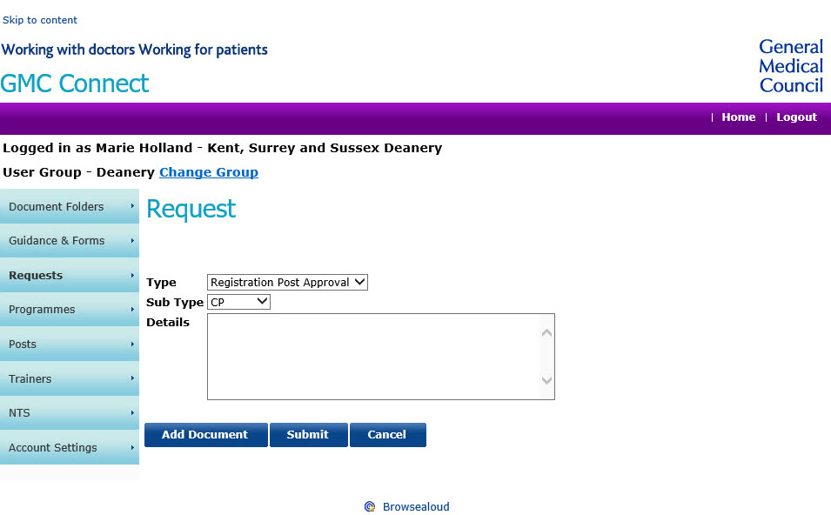
  - Confirmation (by letter / email) from the relevant College that they endorse the appointment.
- The GMC will consider requests for enrolment approval and respond within ten days. If we need more information, we will contact the deanery.
- Once the enrolment is confirmed, the GMC will write to the trainee, their college, and their deanery:
  - confirming that upon successful completion of training, they will be eligible to apply for specialist/GP registration via a combined programme application
  - providing a unique number, to be used by the college when making notifications and recommendations for the award of a CCT for the combined programme.

Applying for specialist/GP registration through the combined programme

Process for application
- Once a trainee has completed the remainder of their programme, their college will recommend them to the GMC.
- A CCT can be issued where a trainee on a combined programme achieves the remainder of all the required professional capabilities, including completion of all required assessments from the point of entry to the programme, which may include a UK exit exam. As long as the deanery and college determine that the professional capabilities have all been achieved and demonstrated to their satisfaction, then a CCT can be issued.
- On application, the GMC will, subject to the doctor meeting all other requirements, grant a CCT.
- If a trainee does not achieve the remainder of all the required professional capabilities within their specialist training programme, the college will be unable to recommend them. This includes passing any required assessment systems, such as exams. Doctors in this position who feel they can evidence their knowledge, skills and experience are equivalent to the relevant curriculum can apply for specialist registration via a standard CESR application. They will need to provide documentary evidence of their knowledge, skills and experience.

Retrospective granting of CCT to CESR(CP) holders
The GMC will grant CCTs retrospectively to doctors who were issued with a CESR through the combined programme prior to 1 January 2021, and who completed the minimum amount of time training in the UK for their specialty, or who trained in a specialty for which there was no minimum training time.
To be retrospectively granted with a CCT doctors will need to make a direct request to the GMC, but will not pay a fee.
If the doctor’s speciality had a minimum training time, we will work with the relevant college to check that the individual met the requirement for minimum UK training time, and then issue the certificate to the doctor.
If the doctor’s speciality had no minimum training time, we will not need to contact the relevant college. A certificate will be issued on verification of completion of a combined programme against the GMC’s records.

Verification of requirements for retrospective requests
Doctors will be asked to contact the GMC to make a retrospective request (for which there is no fee).

Requests for specialities with no minimum training time
The GMC will verify that the doctor has completed a combined programme in their stated speciality. A CCT certificate will then be issued to the doctor.

Requests for specialities with a minimum training time
- GMC receives initial request. The GMC will check that the doctor was issued with a CESR/CEGPR through the combined programme, and if so provide the doctor with a form to complete.
- Once the GMC has received a doctor’s request, we will send this to the relevant college, for verification that the doctor in question completed the required minimum training time.
- The college should provide the GMC with information on all the individual posts the trainee held in their approved programme. This will enable the GMC to determine whether the minimum training time was met. The GMC will pay the college for providing this information.
- The GMC will then confirm to the doctor whether their request has been successful and, where appropriate, issue the CCT.
A list of the required minimum training time for each UK specialty is provided at the end of this guidance.

Annex A - Required minimum training times for all UK specialties
Each specialty which was listed in the Recognition of Professional Qualifications Directive under Annex V of 2005/36/EC (as amended) had a defined minimum number of years training in the UK a doctor must have completed to be eligible for a CCT.

All specialties approved for postgraduate training in the UK were listed in the Postgraduate Medical Education and Training Order 2010 (as amended) along with the minimum training time for specialties where one was in place. As not all CCT specialties in the UK were listed in the Directive, both pieces of legislation have been included below for guidance.

Where a specialty only had a minimum training time listed under the PMET Order, this minimum number of years training can include training undertaken within and outside of the UK.

Where a specialty has no minimum training period listed in either piece of legislation, trainees on the combined programme will be eligible for a CCT.

Doctors on a dual training programme
Where both specialties had a minimum training time under the RPQ Directive, the doctor only needed to train in the UK for the minimum training time specified for one of their specialties. However where applicable, they must have met the higher of the specified minimum training times.
- For example, a doctor training in Endocrinology and Diabetes Mellitus (which has a minimum training time of 3 years) and General (Internal) Medicine (which has a minimum training time of 5 years), would have had to train for a minimum of 5 years in the UK to be eligible for a CCT.
Where one of the doctor’s specialties did not have a minimum training time listed under the Directive, the doctor would still have needed to meet the minimum training time in their other specialty to be granted a CCT.
- For example, a doctor training in General Psychiatry (which has a minimum training time of 4 years) and Old Age Psychiatry (which has no minimum training time), would need to have undertaken a minimum of four years training in the UK to be eligible for a CCT.

Doctors training with a sub-specialty
Doctors training with a sub-specialty must have trained in the UK for the minimum number of years specified for their parent specialty, and time spent training in their sub-specialty in the UK can contribute to this.

Additional training time
Where a doctor undertook additional training time in the UK, for any reason (including an ARCP outcome 3), this can contribute to the minimum UK training time required for eligibility for CCT.

Locum appointments for specialty training
Locum Appointment for Training (LAT) posts can be counted towards a CCT, and therefore towards the amount of training time that a doctor completed in the UK. This is subject to college confirmation that the LAT post was counted towards the CCT.

Required minimum training times for all UK specialties
This list reflects the specialties and minimum training times defined in legislation as of 31/12/2020.
Specialty | Minimum training time under
 | RPQ Directive | PMET Order
Acute internal medicine | N/A | No Minimum
Allergy | N/A | No Minimum
Anaesthetics | 3 | 3
Audio vestibular medicine | N/A | No Minimum
Aviation and space medicine | N/A | 4
Cardiology | 4 | 4
Cardio-thoracic surgery (also known as thoracic surgery) | 5 | 5
Chemical pathology | 4 | 4
Child and adolescent psychiatry | 4 | 4
Clinical genetics | 4 | 4
Clinical neurophysiology | 4 | 4
Clinical oncology | 4 | 4
Clinical pharmacology and therapeutics | 4 | 4
Clinical radiology | 4 | 4
Community sexual health and reproduction | N/A | No Minimum
Dermatology | 4 | 4
Diagnostic neuropathology | N/A | No Minimum
Emergency medicine (also known as accident and emergency medicine) | 5 | 5
Endocrinology and diabetes mellitus | 3 | 3
Forensic histopathology | N/A | No Minimum
Forensic psychiatry | N/A | No Minimum
Gastro-enterology | 4 | 4
General (internal) medicine | 5 | 5
General Practice* | 3
General psychiatry | 4 | 4
General surgery | 5 | 5
Genito-urinary medicine | 4 | 4
Geriatric medicine | 4 | 4
Haematology | 3 | 3
Histopathology | 4 | 4
Immunology | 4 | 4
Infectious diseases | 4 | 4
Intensive care medicine | N/A | No Minimum
Medical microbiology (listed in Annex V as Medical microbiology and virology) | 4 | 4
Medical oncology | 5 | 5
Medical ophthalmology | N/A | No Minimum
Medical psychotherapy | N/A | No Minimum
Medical virology (listed in Annex V as Medical microbiology and virology) | 4 | 4
Neurology | 4 | 4
Neurosurgery | 5 | 5
Nuclear medicine | 4 | 4
Obstetrics and gynaecology | 4 | 4
Occupational medicine | 4 | 4
Old age psychiatry | N/A | No Minimum
Ophthalmology | 3 | 3
Oral and maxillo-facial surgery | 4 | 4
Otolaryngology | 3 | 3
Paediatric and perinatal pathology | N/A | No Minimum
Paediatric cardiology | N/A | No Minimum
Paediatric surgery | 5 | 5
Paediatrics | 4 | 4
Palliative medicine | N/A | No Minimum
Pharmaceutical medicine | N/A | No Minimum
Plastic surgery | 5 | 5
Psychiatry of learning disability | N/A | No Minimum
Public health medicine | 4 | 4
Rehabilitation medicine | N/A | No Minimum
Renal medicine | 4 | 4
Respiratory medicine | 4 | 4
Rheumatology | 4 | 4
Sport and exercise medicine | N/A | No Minimum
Trauma and orthopaedic surgery | 5 | 5
Tropical medicine | 4 | 4
Urology | 5 | 5
Vascular surgery | 5 | 5

As per article 25(2), and Annex V, of the Recognition of Professional Qualifications Directive 2005/36/EC (as amended)
This minimum training time stated is on the basis of full-time training. Those training less than full-time must meet the full-time equivalent training time.

